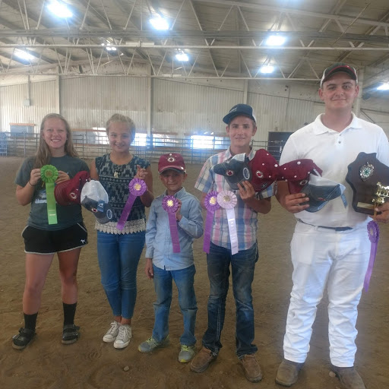
Left to right: Leadsperson Erin Torgerson, Team Members: Kate Quackenbush, Jed Olson, Brock Hoskins, and Ty Harbaugh
Vernon County 4-H Junior Dairy Judging Team places at State Contest:
Four members of the 4-H Junior Dairy Judging Team placed high enough last month at the 4-H Area Animal Science Days Contest in Neillsville, WI that they made it to the State 4-H Dairy Judging Contest held on Monday July 16th in Black River Falls, WI. The team had a great day placing 2nd overall. They won the Holstein and Milking Shorthorn classes and were 2nd in the Ayrshire classes. Ty Harbaugh won the overall individual contest and Brock Hoskins was 4th individual overall. Coaches Ashley Olson and Julie Larson would like to thank all the kids for their hard work this season and also to the producers that allowed us to hold practices at their farms.

